## 2.2.4 The Vision Targets

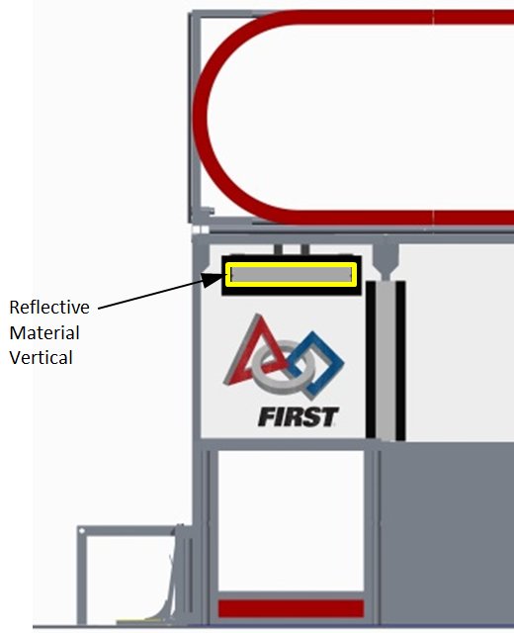 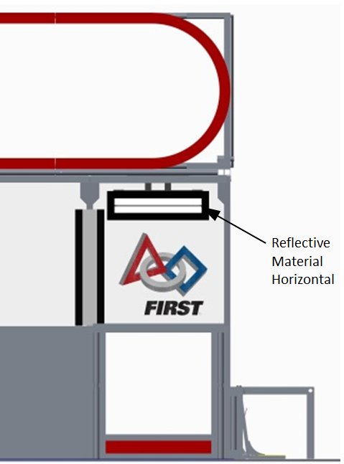

Figure 2-5: The VISION TARGETS

There are four (4) VISION TARGETS on each end of the FIELD: two (2) dynamic VISION TARGETS and two (2) static VISION TARGETS. There is one (1) dynamic VISION TARGET located above each LOW GOAL. Each dynamic VISION TARGET is located behind the polycarbonate panel on the ALLIANCE WALL. The dynamic VISION TARGET is horizontal and begins 5 ft. 8 in. above the FIELD carpet, is centered over the LOW GOAL, and consists of a panel with one (1) 4 in. wide, 1ft. 11 ½ in. long strip of retro-reflective material (3M 8830 Silver Marking Film) adhered horizontally along the length of the panel with a 2 in. black ABS plastic border surrounding the retro-reflective material. The dynamic VISION TARGET is actuated to show the retro-reflective material when its corresponding HIGH and LOW GOAL are HOT. It will rotate to hide the retro-reflective material (pointing it upwards) when its corresponding HIGH and LOW GOAL are not HOT. Both of these conditions are shown in Figure 2-5.

The static VISION TARGET is mounted such that half is behind the polycarbonate sheet above the LOW GOAL and half is behind the acrylic panel of the PLAYER STATION. It uses vertical reflectors which are located above the inside edge of the LOW GOAL. The vertical reflector consists of a 4 in. wide, 2 ft. 8 in. tall stripe of retro-reflective material bordered by 2 in. wide black gaffers tape on the left and right sides. The vertical reflectors begin 3 ft. above the FIELD carpet.